**launching:**

**Overview:**

From densely populated cities to smaller rural profession, waste management systems keep our homes and profession free from unwanted clutter. Although these waste management services exist in every profession, the industry’s current operating standards have proven inefficient resource-intensive. This inefficiency is due to outdated manual collection methods and logistic processes which lack efficient data-driven solutions. The waste management industry is beginning to develop and implement IoT-related solutions to these problems. From waste bins equipped with fill-sensors, to data-based management and logistics platforms, the industry is shifting into a cleaner, more efficient part of modern life and reduces the amount of time and energy required to provide waste management services.

**Purpose:**

By this project one can able to see the present waste details of the dustbins at anywhere and anytime. By this we can monitor the waste details and take care of metropolitan cities.

**Literature Survey:**

**Existing problem:**

            The current process of waste management starts with the waste being created by people in the cities and disposed in trash bins near its creation point. The disposed trash is collected by municipality or private company trucks at the predefined times and transferred to temp collection centres. The trash at the collection cent res is then sent for recycling. This process in current city setting solves the waste problem partially while it creates other problems such as, some trash bins are overfilled while others are under filled by the trash collection time, overfilled trash bins create unhygienic conditions.

**Proposed solution:**

By using lot we can able to develop the coating which shows the waste details like dustbin is full, etc. By this it alerts the municipality or private company trucks or send alert message to the officials and shows the details.

**Theoretical Analysis:**

**Block diagram:**

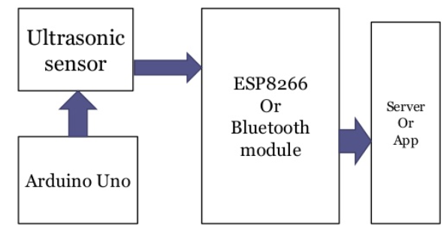

**Figure 1: Block Diagram**

**Hardware/Software designing:**

The hardware parts of the project involves the ultrasonic sensor. The sensor values are read by the NODEMCU , processed, and then sent to the IBM Cloud service using NODEMCU. The data send to mobile coating which was developed using MIT app inventor. Here we use python language for coding. Node-Red, etc. Software tools are used.

**data-based probe:**

There are several IoT hallmark challenges and issues that need to be understood before employing the right security solution that can dynamically vary with the situation. Based on certain critical situations such as IOT waste coating, frequent authorization and authentication are necessary and could dynamically vary, resulting in change to the authorization of IOT devices. To address these issues, automated mutual hallmark without user intervention is required in supporting users from remembering password for a large number of devices.

**Flowchart:**

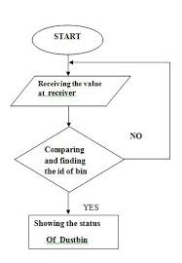

**Result:**

One can see the details of waste at anywhere and time and it alerts the person.

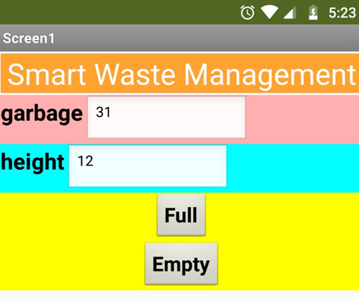

**reward & disfavour:**

**reward of IoT in waste management :**

* It saves time and money by using smart waste collection bins and system equipped with fill level sensors.
* It keeps our surroundings clean and green and free from bad odours of wastes
* Applying smart waste management process to the cities optimize management, resource and costs which makes it a “smart city”.
* It helps governance to generate extra revenue by ad on smart devices.

**disfavour of IoT in waste management :**

* System requires more number of waste bins for separate waste collection as per population in the city.This results into high initial cost due to expensive smart dustbins compared to other methods.
* Sensors node used in the dustbins have limited memory size.
* It reduces the man power essential which results increase in unemployment for unskilled people.

The training has to be provided to the people involved in the smart waste management system.

**Coating:**

* This can be best used by municipal corporation for their betterment of management regarding collection of wastes.
* With the help of proper applied science (GPS & SOFTWARE covering) we can guide the trucks to choose the shortest path.
* It also favours the “SMART CITY” project and “DIGITAL INDIA”.

**Conclusion :**

Waste management provides and cities can benefit from IoT powered smart waste management solution. Using the applied science, waste management companies can increase their functional efficiency, cut cost, and enhance customer satisfaction by make sure no dumpster overflows.

**Future scope:**

The ultimate goal of IoT coating in waste management is producing leaner operations and present higher quality service to citizens. A growing collection of interlinked sovereign systems are managing routine urban functioning and improving both citizen undergo and our carbon footprint. finally, however, we need deeper coordinates between public sectors through a mix of ordinance and incentives and private sectors through a willingness to engage with regional, state, and federal agencies to use IoT covering in waste management to build a better and more sustainable future.

**Bibliography**:

Kolhatkar, Chinmay, Bhavesh Joshi, Prachi Choudhari, and Dhruvin Bhuva. "Smart E-dustbin." In *2018 International Conference on Smart City and Emerging Technology (ICSCET)*, pp. 1-3. IEEE, 2018.

Rohit, G. Sai, M. Bharat Chandra, Shaurabh Saha, and Debanjan Das. "Smart Dual Dustbin Model for Waste Management in Smart Cities." In *2018 3rd International Conference for Convergence in Technology (I2CT)*, pp. 1-5. IEEE, 2018.

Sharma, A. Gopala, Gaddam Sarath Chandu, and N. Srinivasa Rao. &quot;Energy-Efficient Waste Management System Using Internet of Things.&quot; In external Conference on Nanoelectronics, Circuits and Communication Systems, pp. 7-13. Springer, Singapore, 2018.

Singhvi, Rishabh Kumar, Roshan Lal Lohar, Ashok Kumar, Ranjeet Sharma, Lakhan Dev Sharma, and Ritesh Kumar Saraswat. &quot;IoT Based Smart Waste Management System: India prospective.&quot; In 2019 4th external Conference on Internet of Things: Smart design and Usages (IoT-SIU), pp. 1-6. IEEE, 2019.

|  |
| --- |
|  |
|  |
|  |
|  |  |